LAikin BArnard 6955

Formative Assessment 2 CW412

Contents

Question: 2

Instructions: 2

Answer the following questions: 2

Solution: 3

My web page: 3

HTML CODE: 4

CSS CODE: 5

# Question:

## Instructions:

* Use Visual Studio 2017/2019 or Notepad++ to complete your practical.
* Provide screenshots of your webpage with coding on a PDF Document.
* Upload PDF file and visual studio/Notepad project to colcampus.

## Answer the following questions:

1. Using HTML5 and CSS3, Create the following webpage as illustrated below.



# Solution:

## My web page:

The completed web page.

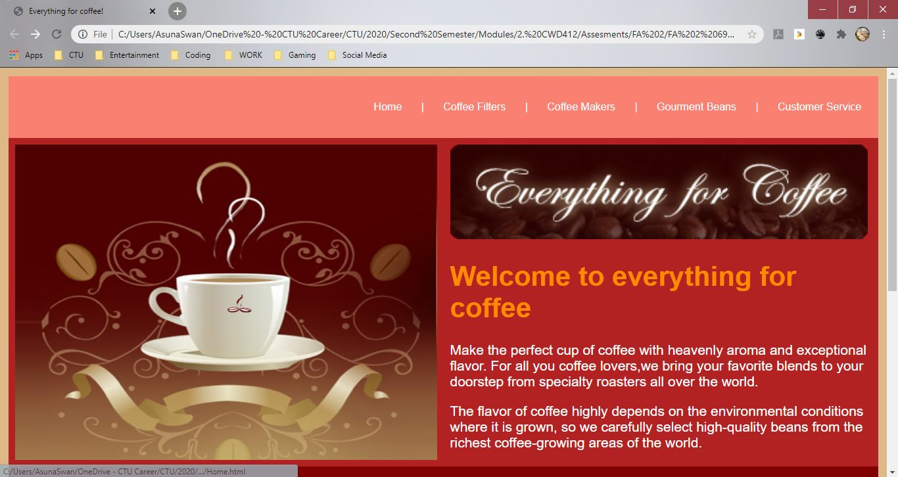

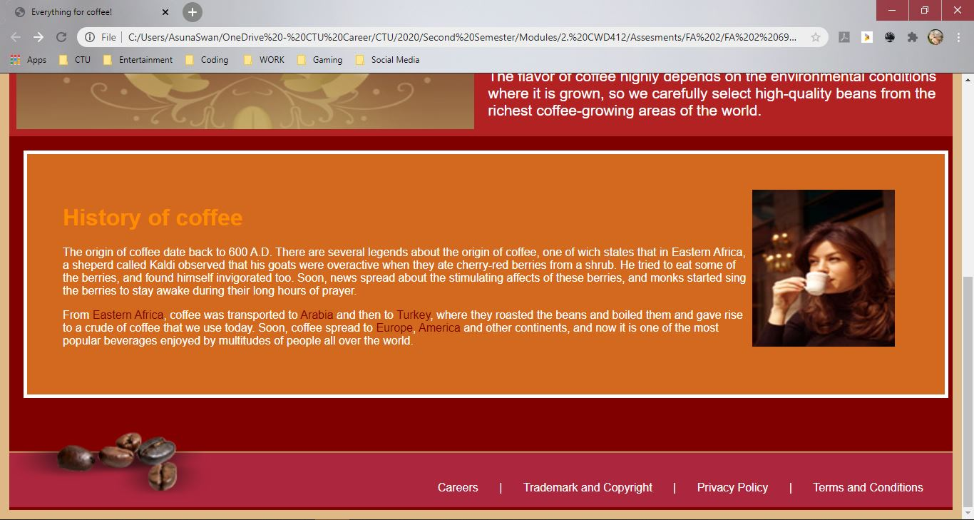

## HTML CODE:

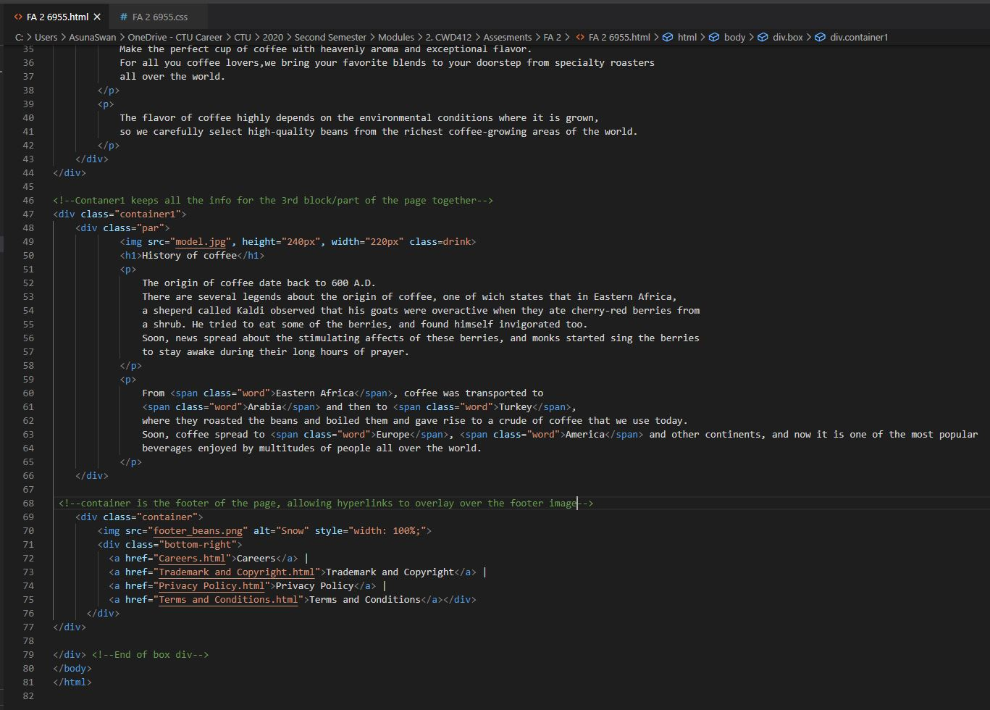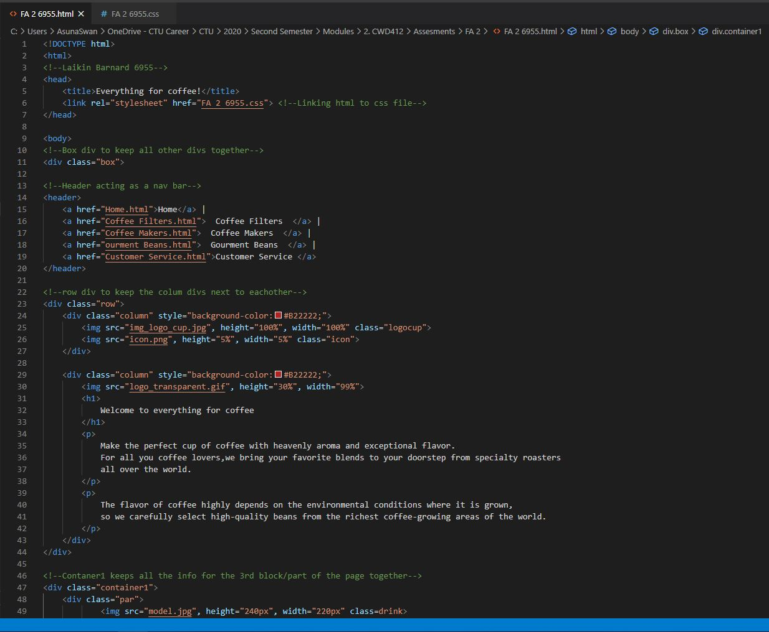

## CSS CODE:

